**Manage Azure Governance**

* Resource Tags
* Managing Subscription Policies
* Azure Blueprints

### Resource Tags

You can apply tags to your Azure resources to logically organize them by categories. Each tag consists of a name and a value. For example, you can apply the name "Environment" and the value "Production" or "Development" to your resources. After creating your tags, you associate them with the appropriate resources.

With tags in place, you can retrieve all the resources in your subscription with that tag name and value. This means, you can retrieve related resources from different resource groups.

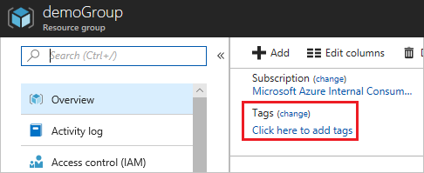

Perhaps one of the best uses of tags is to group billing data. When you download the usage CSV for services, the tags appear in the Tags column. For example, you could group virtual machines by cost center and production environment.

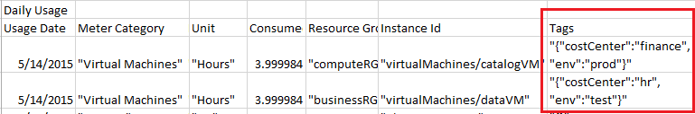

There are a few things to consider about tagging (more at the reference link):

* Each resource or resource group can have a maximum of 15 tag name/value pairs.
* Tags applied to the resource group are not inherited by the resources in that resource group.
* Tag names are limited to 512 characters, except for storage accounts, which are limited to 256.
* Tag values are limited to 256 characters, except for storage accounts, which are limited to 128.

**Azure Policies**

* Azure Policy is a service in Azure that you use to create, assign and manage policy definitions.
* Policy definitions enforce different **rules and actions** over your resources, so those resources stay **compliant** with your corporate standards and service level agreements.
* Azure Policy does this by running an evaluation of your resources, scanning for those not compliant with the policy definitions you have. For example, you can have a policy to allow only certain type of virtual machines. Another requires that all resources have a particular tag. These policies are then evaluated when creating and updating resources.

## About Policy definition:

## A Policy Definition expresses what to evaluate and what actions to take. Every policy definition has conditions under which it is enforced. And, it has an accompanying effect that takes place if the conditions are met.

* **Allowed Virtual Machine SKUs**: This policy enables you to specify a set of virtual machine SKUs that your organization can deploy.
* **Allowed Storage Account SKUs**: This policy definition has a set of conditions/rules that determine if a storage account that is being deployed is within a set of SKU sizes. Its action is to deny all servers that do not adhere to the set of defined SKU sizes.
* **Require SQL Server 12.0**: This policy definition has conditions/rules to ensure that all SQL servers use version 12.0. Its action is to deny all servers that do not meet these criteria.
* **Allowed Resource Type**: This policy definition has a set of conditions/rules to specify the resource types that your organization can deploy. Its action is to deny all resources that are not part of this defined list.
* **Not allowed resource types**: This policy enables you to specify the resource types that your organization cannot deploy.
* **Allowed Locations**: This policy enables you to restrict the locations that your organization can specify when deploying resources. Its action is used to enforce your geo-compliance requirements.
* **Apply tag and its default value**: This policy applies a required tag and its default value, if it is not specified by the user.
* **Enforce tag and its value**: This policy enforces a required tag and its value to a resource.

## About Initiative definition:

## An initiative definition is collection of policy definitions that are tailored towards achieving a singular goal.

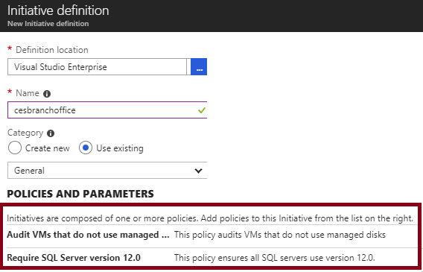

**To implement Azure Policies, you can follow these steps.**

**Roles Requirement for Policy:**

* The **Resource Policy Contributor** role includes most Azure Policy operations.
* **Owner** has full rights.
* **Contributor** may trigger resource remediation, but can't create or update definitions and assignments.
* Both **Contributor** and **Reader** have access to all read Azure Policy operations.
* **User Access Administrator** is necessary to grant the managed identity on **deployIfNotExists** or **modify** assignments necessary permissions.
* All policy objects will be readable to all roles over the scope.

**Examples:**

1. Add a tag to resources: **Effect**=**Modify**
2. Configure backup on virtual machines without a given tag to an existing recovery services vault in the same location: **Effect**: **deployIfNotExists**

**Create Azure Policy to allow resource creation only in particular region**

## Policy 🡪 Definitions 🡪 Filter: Search = Location 🡪 Select Allowed locations

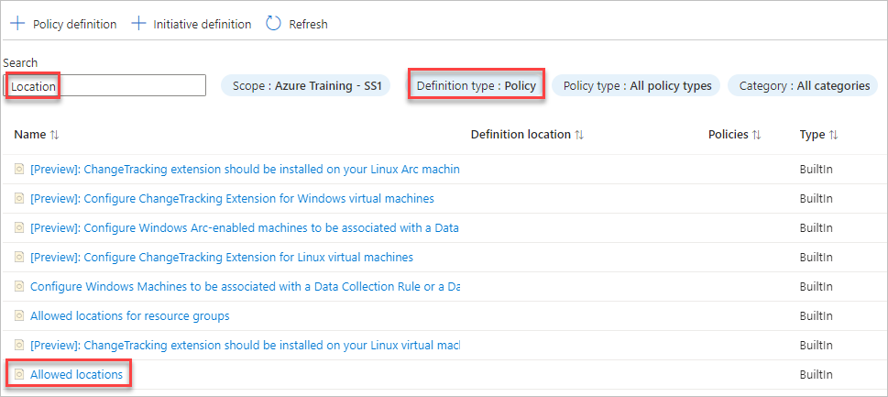

1. Review the Definition and click on **Assign** (in top)
2. Basics Tab:
   1. Scope = <your subscription>
   2. Next
3. Advanced Tab: No changes
4. Parameters Tab 🡪 Allowed Locations: Select East US and East US2

1. Remediation: No changes
2. Non-compliance messages: Non-compliance message = This location not allowed
3. Review + Create 🡪 Create
4. Try creating a storage account in any other region and note the error…

**2nd Example: Adding a Tag to a Resource**

## Policy 🡪 Definitions 🡪 Filter: Search = Add a tag to resources 🡪 Select Add a tag to resources

1. Review the Definition and click on **Assign** (in top)

1. Basics Tab:
   1. Scope = <your subscription>
   2. Next
2. Advanced Tab: No changes
3. Parameters Tab 🡪
   1. Tag Name = Owner
   2. Tag Value = Sandeep
4. Remediation:
   1. Check, Create a remediation task
5. Non-compliance messages: Non-compliance message = The required tag is missing
6. Review + Create 🡪 Create
7. Create a Storage Account and note that it has automatically got the tag Owner.

### Determine Compliance

Once your policy is in place you can use the Compliance blade to review non-compliant initiatives, non-compliant policies, and non-compliant resources.

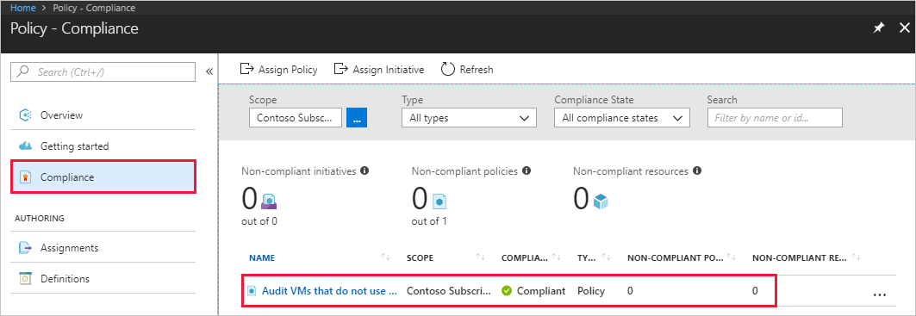

Note: Policy evaluation happens about once an hour, which means that if you make changes to your policy definition and create a policy assignment then it will be re-evaluated over your resources within the hour.

**Azure Blueprints**

Azure Blueprints is a declarative way to orchestrate the deployment of such artifacts as policy

* Role assignments
* Policy assignments
* Resource groups
* ARM templates

How is this different from ARM templates ?

**Azure Policy vs. Azure Blueprints**

**Azure Policy**

* Helps to enforce organizational standards and to assess compliance at-scale.
* Provides an aggregated view to evaluate the overall state of the environment.
* Helps to bring your resources to compliance through bulk remediation for existing resources and automatic remediation for new resources

**Azure Blueprints**

* Enables cloud architects and central information technology groups to define a repeatable set of Azure resources that implements and adheres to an organization's standards, patterns, and requirements.
* Makes it possible for development teams to rapidly build and stand up new environments with trust they're building within organizational compliance.